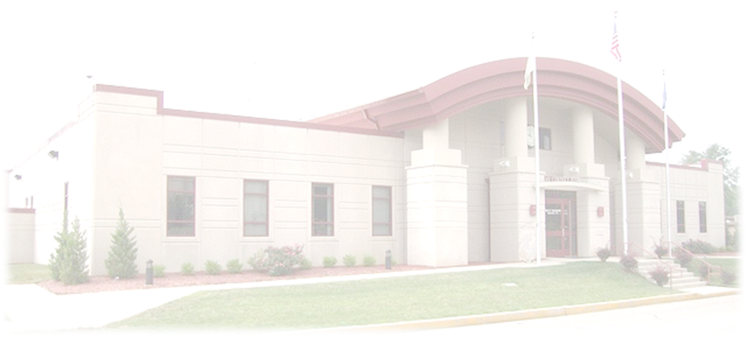
CLAY COUNTY SHERIFFS OFFICE
PRE-APPLICATION FORM

611 E Jackson St Complete form and email to:
Brazil, Indiana 47834 Clay County Sheriff’s Office
(812) 446-2535 (Main) Attn: Josh Clarke
(812) 446-0941 (Fax) sheriffsoffice@claycountyin.gov
Personal Information

Name: ______________________ ______________________ ______________________
Last First Middle

Address: _______________________________ _____________________ __________
Street City/State Zip Code

Social Security Number: ___________________ Date of Birth: ______________________

Phone: _________________________ (Home) ____________________________ (Cell)

Highest Level of Education Completed:
High School Diploma/GED Some College Associate’s Degree Bachelor’s Degree Master’s Degree of Higher

Are you a U.S. Citizen?: Yes No

Are you an Indiana Law Enforcement Academy Graduate?: Yes No

Have you had prior experience as a police officer with another department, either currently or in the
past?: Yes No

Have you ever been arrested and/or convicted of a misdemeanor or felony crime?: Yes No

If yes, please provide a brief explanation: __________________________________________
____________________________________________________________________________

Do you possess a valid driver’s license?: Yes No

License State: __________________ License Number: ____________________

Has your driver’s license ever been suspended or revoked?: Yes No

If yes, please provide a brief explanation: __________________________________________
____________________________________________________________________________

Applicant Signature: ___________________________________ Date: _______________________

It is the applicant’s responsibility to keep the Clay County Sheriff’s Office informed of any addresses or telephone number changes.

You will be emailed information regarding the date(s) and time(s) of any future phases of the Applicant Process when the information becomes available.
Thank you for your interest in the Clay County Sheriff’s Office

